Data Structure and Algorithm

Laboratory Activity No. 6

Singly Linked Lists

|  |  |
| --- | --- |
| *Submitted by:* | *Instructor:* |
| Caasi, Karl Benedict D. | Engr. Maria Rizette H. Sayo |

August 23, 2025

# Objectives

Introduction

A linked list is an organization of a list where each item in the list is in a separate node. Linked lists look like the links in a chain. Each link is attached to the next link by a reference that points to the next link in the chain. When working with a linked list, each link in the chain is called a Node. Each node consists of two pieces of information, an item, which is the data associated with the node, and a link to the next node in the linked list, often called next.

This laboratory activity aims to implement the principles and techniques in:

* Writing algorithms using Linked list
* Writing a python program that will perform the common operations in a singly linked list

# Methods

* Write a Python program to create a singly linked list of prime numbers less than 20. By iterating through the list, display all the prime numbers, the head, and the tail of the list. (using Google Colab)
* Save your source codes to GitHub

# Results

Present the visualized procedures done. Also present the results with corresponding data visualizations such as graphs, charts, tables, or image . Please provide insights, commentaries, or explanations regarding the data. If an explanation requires the support of literature such as academic journals, books, magazines, reports, or web articles please cite and reference them using the IEEE format.

Please take note of the styles on the style ribbon as these would serve as the style format of this laboratory report. The body style is Times New Roman size 12, line spacing: 1.5. Body text should be in Justified alignment, while captions should be center-aligned. Images should be readable and include captions. Please refer to the sample below:

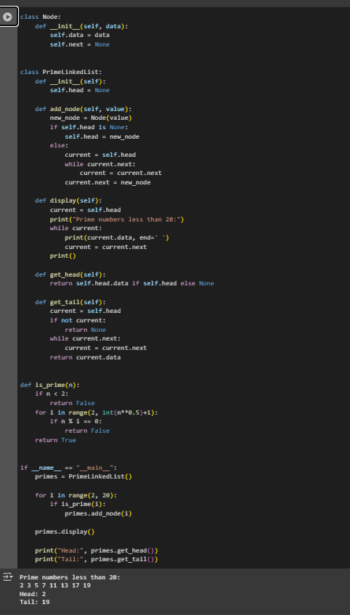

Figure 1 Screenshot of program

This Python program shows how to create and manage a simple singly linked list that stores all prime numbers less than 20. It starts by defining a Node class to hold each prime number and a pointer to the next node. The Prime LinkedList class handles the list operations, such as adding nodes, displaying the list, and getting the first and last elements. A helper function called is prime checks if a number is prime. In the main part of the program, numbers from 2 to 19 are checked, and the primes are added to the **Conclusion**This Python program efficiently demonstrates how to create and manage a singly linked list containing all prime numbers less than 20. It highlights fundamental concepts such as defining custom classes for nodes and linked lists, adding elements to the list, traversing and displaying the list, and retrieving the first (head) and last (tail) elements. The program also incorporates a simple prime-checking function that verifies each number before adding it to the list. Overall, this implementation serves as a clear and practical example for understanding both linked list data structures and basic prime number logic in Python.  
 **References**

* python Official Documentation: https://docs.python.org/3/
* W3Schools Python Classes and Objects: https://www.w3schools.com/python/python_classes.asp